Chapter 1 Question 19 Michael Streyle

##   
## Call:  
## lm(formula = GPA ~ ACT)  
##   
## Coefficients:  
## (Intercept) ACT   
## 2.11405 0.03883

## Analysis of Variance Table  
##   
## Response: GPA  
## Df Sum Sq Mean Sq F value Pr(>F)   
## ACT 1 3.588 3.5878 9.2402 0.002917 **  
## Residuals 118 45.818 0.3883   
## ---  
## Signif. codes: 0 '***' 0.001 '**' 0.01 '*' 0.05 '.' 0.1 ' ' 1

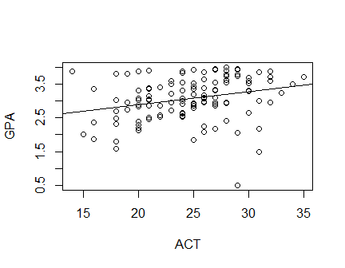

## (Intercept)   
## 3.278863

## (Intercept)   
## 3.31769

The intercept is 2.11 GPA units and the slope is 0.0388 GPA unit per ACT score increment.